BAKI UNİVERSİTETİNİN XƏBƏRLƏRİ
№3 Təbiət elmləri seriyası 2014

GEOLOGİYA

LESSER CAUCASUS – EAST IRAN, MIDDLE EAST: SOME MATERIALS ON GEOLOGY AND METALLOGENY, “HOT” TECTONICS DUE TO THE AFRICAN SUPERPLUME ACTIVITY, MELT AND FLUID INCLUSIONS; DIFFERENT DATA ON HYDROCARBONS (HC), PROBLEMS, AND CONSTRAINTS

N.A.IMAMVERDIYEV*, A.ROMANKO**, SH.F.ABDULLAYEVA, V.PROKOFIEV***, I.VIKENTIEV***, A.SAVICHEV**,
S.STEPANOV**, M.HEIDARI*, B.RASHIDI*****
*Baku State University, Baku, Republic of Azerbaijan
**Geological Institute, Academy of Sciences (RAS),
Moscow, Russian Federation
***Institute of geology of ore deposits, Academy of Sciences (RAS),
Moscow, Russian Federation
****Parsi Kan Kav, Tehran, Iran
*****Satrap Resources, Perth, Australia
inazim17@yahoo.com, a-romanko@ya.ru; a.romanko@yahoo.com

Cenozoic tectonic-magmatic-metallogenic events in the Lesser Caucasus and East Iran, Middle East have some common similarities. Important geological – metallogenic +- OIL / HC correlation for the Alpine time exists (metallogeny of East Iran led by outstanding regional trio: E. Romanko, A. Houshmandzadeh, and M.A.A. Nogole-Sadat). Geological northeastern (NE) zoning and “hot” tectonics due to the African superplume activity including, probably, known delamination of lithospheric mantle during collision of mantle lithosphere ca. 13 Ma is principal here. Intraplate alkaline- subalkaline rocks of the region studied including Quaternary real carbonatites of Hanneshin, Afghanistan were derived from the enriched African superplume-related mantle sources being enriched in HFSE - Nb, Ta, Zr, Y, P, Ti etc. Late Cenozoic High-K calc-alkaline rocks in the Lesser Caucasus could be deal with African superplume activity too despite their subduction-related rock geochemistry. Important data exist about a general meridianal-close (ca. N-S) zoning of oil / hydrocarbons (HC), muds, salts etc. here. This is one of arguments in favor of deep HC input alongside to traditional HC interpretation too. Large regional economic Cu-Au porphyry etc. metallogeny deals mainly with Eocene (Pg²) shoshonite – latite series rocks formed during known subduction of Arabian plate beneath the Central Iran.

Key words: Central part of the Alpine-Himalayan mobile belt, Lesser Caucasus – East Iran, Middle East, geology, geochemistry, tectonics, magmatism, metallogeny, African superPlume, delamination, mineralogy, melt and fluid inclusions, northeastern (NE) tectonic-magmatic-metallogenic +- oil / hydrocarbons (HC) zoning.

Introduction
Central part of the famous and fantastically interesting Alpine – Himalayan mobile belt is geologically, economically… extremely important, however, very irregular investigated region. Great importance of its regional study is obvious, surely. Lesser Caucasus is geologically better known versus East Iran. Poorly studied East Iran close to the very Alpine – Himalayan tectonic junction (Khain, Leonov, 1988; also in many other works as follows: Stocklin et al., 1965; Nogole-Sadat, 1985; Houshmandzadeh et al., 1986;Imamverdiyev, 2000; E. Romanko et al, 1984; Milanovsky, Koronovsky, 1973 etc. and etc.) studied by us under the leadership of outstanding metallogenic trio – known regional specialists Dr. E. Romanko, Dr. A. Houshmandzadeh, and Dr. M.A.A. Nogole-Sadat. We present some new data on this intriguing region.
Review of Geology and Results
General geology and tectonics of this economically and geologically interesting region were described in such works as follows: (Khain, 2001; Imamverdiyev, 2000; Milanovsky, Koronovsky, 1973; Leonov et al, 2010; Trifonov, Ruzhentsev, 1984, etc., fig. 1-2).
Two groups of magmatic rocks were revealed here as: mainly Eocene shoshonitic-latitic etc. rocks of the first group and principally other rocks - Neogene – Quaternary intraplate subalkaline and alkaline ones, second group.
Rocks of the first group (subduction-related differentiated rocks) are the products of a large subduction of the Arabian plate beneath the Central Iran block (Fig. 1). This subduction is confirmed by the regional tectonic analysis (Khain 2001; Leonov et al., 2010), High-resolution tomography by known J. Ritsema’s team (Bull et al., 2009 etc.), geochemistry (Imamverdiyev, 2000; Romanko et al., 2013; etc., fig. 1) etc. Catastrophic earthquakes as 8 M and more by the Richter scale, unfortunately, are not rare here. A recent catastrophic example is 2003 Bam earthquake in East Iran with a lot of casualties.
Antipodes of the second group related to African superplume activity are: intraplate K-Na subalkaline and alkaline rocks – High-Ti trachybasalts, trachyandesites, real Quaternary carbonatites of Hanneshin, Afghanistan, Late Cenozoic carbonatites of Arabia, also Neogene lamproites of Algeria etc. by E. Romanko et al., 1988 and Romanko et al., 2013 (tables 1-10, fig. 1-2, 9-11; Bogatikov et al., 1987; Luchitsky, 1985, Yarmolyuk et al., 2001, Knipper et al., 1992 etc.).
These intraplate rocks, in contrast to subduction-related calc-alkaline and other rocks, are characterized by an enrichment in both LILE - K, Rb, Ba, Cs and HFSE - Nb, Y, Ta, Zr, Ti, P, etc. (Tables or tab. 1, 5-11, fig. 3) with a characteristical positive Eu/Eu* - more than 1.0-1.1. Also, increased content of P₂O₅ - sometimes more than 1.0% (very high) - is a characteristic feature of intraplate rocks.

Fig 1. Magmatic complexes in Lesser Caucasus using
(Dilek, Imamverdiyev, Altunkaynak, 2010)

We have received fair low isotopic data ⁸⁷Sr/⁸⁶Sr (ISr) in two samples of intraplate rocks of the second type - trachyandesites R70-2 – 0.7039 ÷ 0,2 (high K/Rb=393) and trachybasalt R71-4 – 0.70489 ÷ 0,18 (K/Rb=375, fig. 4). For subduction-related calc-alkaline andesite of stratovolcano Bazman, sample R-25 was determined a rather low value ISr = 0.70456 ÷ 0.05, K/Rb=250 (tab. 1). Isotopic data of these our intraplate rocks differ from collisional and subduction-related rocks from Anatolia, Turkey (Khain, 2001; Imamverdiyev, 2008 etc.). Igneous rocks of the volcanic rocks are fully differentiated series of the regional known Sahand – Bazman belt. Known mainly andesite stratovolcanoes in this belt are: Bazman with a height 3490m and Taftan - 3940m (old mark was 4042m). Old 0.7049 isotopic date for a ‘volcanite’ of an unnamed volcano in a desert was reported by Canadian team (Camp, Griffis, 1982).

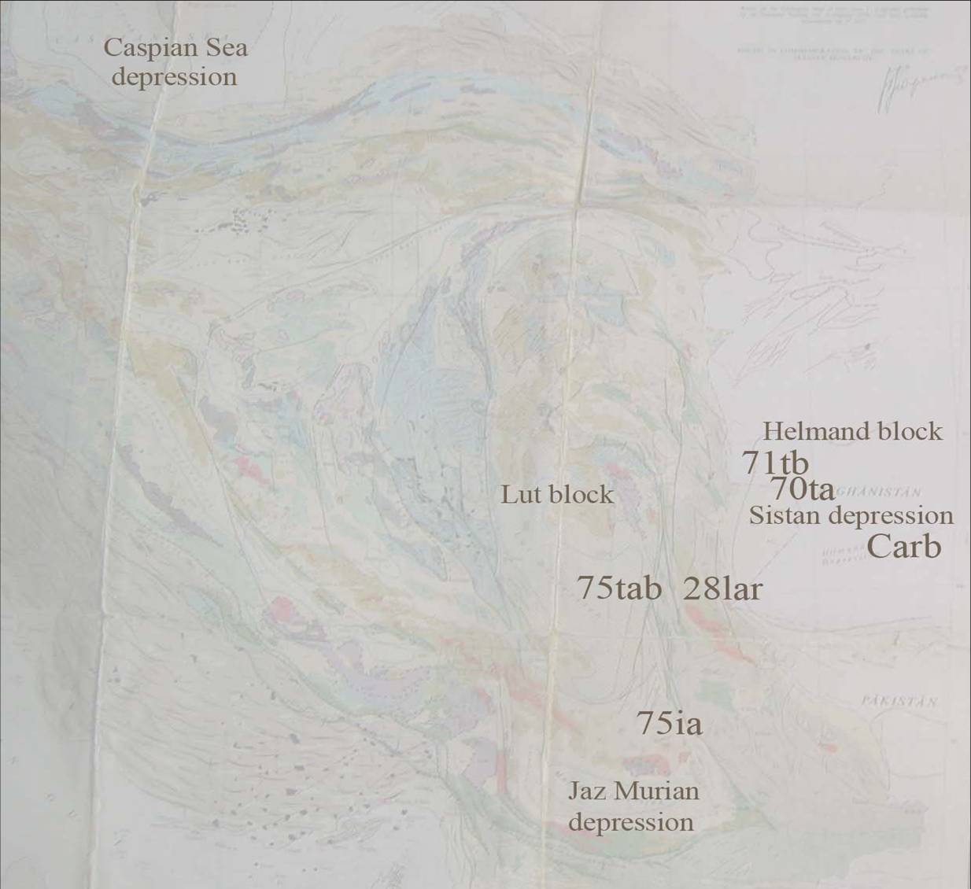
Abbas Abad
Fig. 2. Magmatic rocks sample position in East Iran using Geological map scale 5: 000 000. R-70, R-71 – intraplate rocks in Sistan, R-75ia - High K-dacite with a high crystallization temperature as shown in text, Carb = carbonatites of Hanneshin, Afghanistan, R-28 – Lar alkaline intrusion with Cu-Au mineralization, Abbas Abad – important area with Cu deposits, tab = basic trachyandesite, tb = trachybasalt.

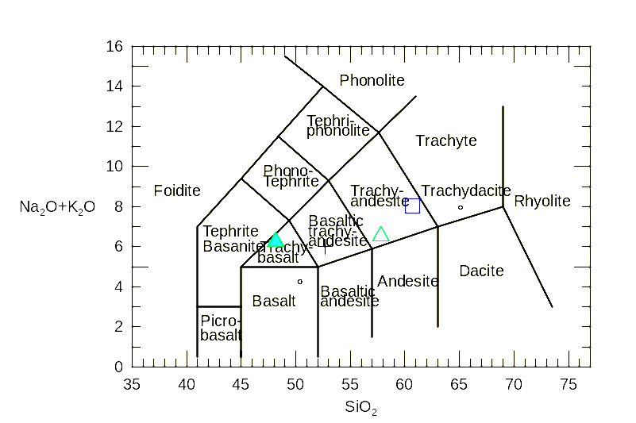
Fig.3. Na₂O+K₂O (wt %) versus SiO₂ (wt %) or TAS diagram. Triangules - intraplate rocks of East Iran, quadrangle – Lar Low-Ti intrusive massif with Cu-Au mineralization. Dot – trachydacite of shoshonite – latite series, Kurama zone, Tien-Shan, C3-P1, analogue of Pg2 shoshonite – latite studied series (Lesser Caucasus - East Iran etc.)

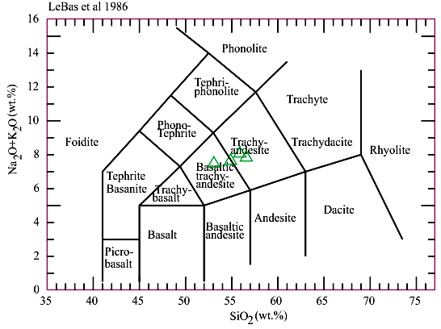

Fig.4. Na₂O+K₂O (wt %) versus SiO₂ (wt %) or TAS diagram for the Abbas Abad Cu-mining area, Central Iran (NE Iran by a formal geography), Pg2? Samples of M. Heidari et al.

Table 1
Major- and trace-element composition in the rocks studied
Sample | 1 | 2 | 3 | 4 | 5 | 6 | 7 | 8 | 9
SiO₂  TiO₂  Al₂O₃  Fe₂O₃  FeO  MnO  MgO  CaO  Na₂O  K₂O  P₂O₅  Rb  Ba  Sr  Ni  Co  Cr  V  Cu  Zn  Pb  Zr  Y  Nb  Sc  Th  U  La  Ce  Nd  Sm  Eu  Gd  Tb  Er  Yb  K/Rb | 48.17  2.20  3.80  9.32  2.56  0.14  5.75  8.98  4.93  1.31  0.23  30  375  1185  86  33  64  220  63  113  5  283  25  23  19  3  1.2  44  101  -  -  -  -  -  -  -  560 | 57.80  1.31  17.48  4.37  1.07  0.09  2.27  7.10  5.11  1.42  0.61  19  293  912  53  14  60  95  65  88  20  232  19.5  17  10.7  3.65  0.99  32.4  68.3  31.4  6.00  2.11  5.08  0.78  1.64  1.26  620 | 54.50  1.87  15.94  6.39  0.40  0.09  3.37  7.58  5.81  1.73  1.05  20  -  4470  58  -  38  -  64  113  51  339  25  19  -  -  -  -  -  -  -  -  -  -  -  -  586 | 54.00  1.52  -  6.25  -  0.08  -  7.40  -  1.09  -  15  292  950  59  -  <64  -  77  98  5  217  15  -  26.2  4.84  1.31  30  63  -  -  -  -  -  -  -  581 | 60.69  0.36  15.32  2.70  2.07  0.09  3.65  3.90  3.64  4.38  0.31  145  1230  870  50  12  50  81  69  32  20  96  15  5.8  10  12  1  18  32  -  -  -  -  -  -  -  245 | 65.39  0.42  13.71  3.25  -  0.057  1.39  2.08  2.87  4.51  0.11  117  577  232  7  5  16  63  15  40  27  158  11  8  -  -  -  -  -  -  -  -  -  -  -  -  307 | 65.10  0.51  15.54  2.42  2.32  0.13  1.72  2.80  3.36  4.59  0.20  109  1597  359  13  6  18  54  11  57  22  246  29  12  -  16.7  4.62  34.0  64.5  27  5.6  1.3  4.1  -  1.9  1.7  350 | 85.00  0.60  4.00  3.21  1.10  0.02  0.52  0.29  0.28  0.21  0.09  7  390  440  10  4  11  55  17  8  20  136  13  6  6.5  1  3  15  28  -  -  -  -  -  -  -  230 | 58.67  1.70  15.13  6.69  2.19  0.09  2.28  1.77  5.06  2.05  0.30  47  557  263  44  21  72  107  33  82  10  219  23  30  10  12  3  35.2  64.2  25.0  5.1  1.9  4.8  0.9  1.6  1.6  350
1 and 2 - trachybasalt (sample R71-4) and trachyandesite (sample R70-2) correspondently, Haji lake, Neogene (?), Afghan block, 3 - trachyandesite, Baluchestan, Iran (Camp, Griffis, 1982), 4 - trachyandesite, R75wp, Lut block, 5 - syenite, Lar intrusiion with Cu-Au mineralization, Miocene(?) 6 – K-dacite, R75, Lut block, and 7 - trahydacite, standard, Kurama Ridge Middle Tien Shan, Karamazar, Tajikistan, Late Carboniferous - Early Permian, using data and extrapolation from (Rusinov, Kovalenker, 1991; Razdolina, Moralev et al., 1993; Mamajanov, 2005; Romanko et al., 1989) 8 - leucorhyolite, R-82, East Bazman volcano, Quarternary(?), 9 - trachyandesite, continental rift, standard, Proterozoic, Pechenga area, Fennoscandian or Baltic shield, by Romanko et al., 1989.
Table 2
Chemistry of melt inclusions glass (wt %) in plagioclase (1, 3), host mineral (2, 4), host acid K-volcanite (5), leucorhyolite from Bazman
stratovolcano, and plagoclase standards (7-9) due to A. Betekhtin, 1953.
sample | SiO₂ | TiO₂ | Al₂O₃ | FeO | MnO | MgO | CaO | Na₂O | K₂O | P₂O₅ | Cl | S | Sum
1 | 74.77 | 0.19 | 12.94 | 0.58 | 0.08 | 0.12 | 1.52 | 3.88 | 3.93 | 0.26 | 0.00 | 0.01 | 98.28
2 | 58.69 | 0.01 | 24.77 | 0.23 | 0.00 | 0.01 | 6.68 | 7.22 | 0.49 | 0.00 | 0.00 | 0.01 | 98.11
3 | 74.48 | 0.15 | 14.53 | 0.53 | 0.04 | 0.10 | 1.69 | 3.02 | 4.10 | 0.00 | 0.01 | 0.01 | 98.66
4 | 58.36 | 0.00 | 24.71 | 0.28 | 0.02 | 0.05 | 7.15 | 6.90 | 0.46 | 0.04 | 0.00 | 0.01 | 97.98
5  6  7  8 | 65.39  85.00  58.16  56.05 | 0.42  0.60  -  - | 13.71  4.50  26.57  28.01 | 2.93  3.98  -  - | 0.06  0.02  -  - | 1.39  0.52  -  - | 2.08  0.29  8.35  10.1 | 2.87  0.28  6.92  5.89 | 4.51  0.21  -  - | 0.11  0.09  -  - | -  -  -  - | - | -  -  -
9 | 62.43 | - | 23.70 | - | - | - | 5.03 | 8.84 | - | - | -
1, 3 - melt inclusions glasses in plagioclase, 2, 4 - host minerals, 5 – hosted Hi-K-volcanite, sample R-75, 6 – leucorhyolite from stratovolcano Bazman, Quaternary(?), 7-9 plagioclase standards: 7 - andesite, SiO₂ = 58.16, empirical formula - Na_{0.6}Ca_{0.4}Al_{1.4}Si_{2.6}O₈, chemical formula andesite - (Na, Ca) (Si, Al)₄O₈, Webmineral.com, 8 - 9 - plagioclase theoretical composition: An₅₀ (8) and An₂₅ (9), by A. Betekhtin, Moscow, 1953.

Table 3
Sum of gases by thermobarogeochemistry (cub. cm / kg)
Sample | Sum of gase  (Cubic cm/kg) | Rock, age, notes
1. R26 | 0.933 | subvolcanites and shallow intrusions, West Taftan volcano, diorites, probably Miocene
2. R38 | 1.022 | Lar intrusion, Oligocene-Miocene
3. R61 | 0.401 | ophiolites, Cretaceous
4. R85 | 0.655 | ophiolites, Cretaceous
5. R35 | 12.942 | Subvolcanites intruding CARBONATIC rocks, West Taftan stratovolcano, maximal contain, probably Oligocene-Miocene. Highest content.
6. R66 | 1.262 | Young Cu-Zn-Pb mineralization with Au and Ag, Taftan stratovolcano, probably Quaternary

Sum of gases includes H₂, O₂, N₂, CO₂, CH₄, C₂H₆, C₃H₈, C₄H₁₀, C5H12, and C₆H₁₄. Temperature of Au mineralization is 220 – 278ºC, Oligocene-Quaternary, important Lar intrusive massif with Au up to 25.4 ppm, T = 220–226ºC by analyst R. Mudrogova, VNIIYG GB or Nuclear geophysics Institute, Moscow region (E. Romanko et al., 2000). Maximum of gases are in subvolcanites intruding CARBONATIC rocks. Minimum of gases are in ophiolite mélange rocks.

Table 4
⁸⁷Sr/⁸⁶Sr (ISr) isotopic data from the rocks
Sample | ⁸⁷Sr/⁸⁶Sr | Rock, mineral, age, notes
1. | 0,7039+-0,0002 | Trachyandesite, sample R-70-2, Hilmand (Afghan) block, maybe Neogene
2. | 0,70489+-0,00018 | trachybasalt, R71-4, lake Haji area, Hilmand (Afghan) block, maybe Neogene
3. | 0,70456+-0,00005 | calk-alkaline basic andesite, R-25-1, East Bazman volcano, Neogene-Quaternary
4. | 0,7049 | ‘volcanite’ by Camp and Griffis, 1982, No data about age
5. | 0,7047+-0,0003 | biotite from trachybasalt, sample 64, Shurab - Galecha, Eocene
6. | 0,7048+-0,0003 | dacite, sample 166, Eocene
7. | 0,7051 | andesite, sample 206, Eocene
8. | 0,7055 | biotite from andesite, sample 203, Cheh-meh-Huri, Eocene
9. | 0,7059 | andesite, sample 193-A, no age data
10. | 0,7051 | biotite from dacite, sample 143, Gazu area, no age
11. | 0,7043 | granodiorite, sample 146, no age data
12. | 0,7045 | granodiorite, sample 151, no age data
13. | 0,7051+-0.0003 | biotite from granodiorite, Gazu area, Campanian
14. | 0,7048+-0,0003 | biotite from dacite, Shurab-Galecha, Eocene
15. | 0,7056+-0.0002 | plagioclase from dacite, Eocene
16. | 0,7065+-0.0003 | biotite from dacite, Kuh-Berg, Eocene
17. | 0,7070+-0.0003 | granodiorite, Sor-Kuh, Middle Jurassic
18. | 0,7041+-0.0001 | Late Cenozoic magma, ENd= +4.1 +- 0.2, Great Caucasus
19. | 0,7040 | Late Cenozoic magma, ENd= +3, Great Caucasus

1-3 - author’s data, 4 - after (Camp, Griffis, 1982), 5-9 – Lut block, immediately west from
East Iranian zone, after Sandwall E., Turkell N. Zor E. et al., 2003;
18-19 – Geat Caucasus, courtesy of I. Chernyshev, S. Bubnov, A. Lebedev et al., IGEM, RAS, Moscow.

Table 5

Major elements composition in the rocks

Sample | 1 | 2 | 3 | 4 | 5 | 6 | 7 | 8 | 9 | 10 | 11 | 12 | 13
SiO₂  TiO₂  Al₂O₃  Fe₂O₃  FeO  MnO  MgO  CaO  Na₂O  K₂O  P₂O₅ | 48.17  2.20  13.80  9.32  2.56  0.14  5.73  8.98  4.93  1.31  1.11 | 49.0  1.69  14.1  9.10  - 0.11 9.23 7.72 3.06 1.84 0.40 | 52.76  1.11  17.44  3.14  5.40  0.13  5.55  8.62  3.46  1.31  0.40 | 54.50  1.87  15.94  6.39  0.40  0.09  3.37  7.58  5.81  1.73  0.51 | 56.95  1.27  16.40  5.28  0.46  0.08  3.35  6.80  5.33  1.50  0.59 | 57.80  1.31  17.48  4.37  1.07  0.09  2.27  7.10  5.11  1.42  1.05 | 35.10  0.74  13.48  7.53  0.73  0.16  5.46  26.66  0.80  0.10  0.16 | 44.26  0.81  12.70  4.81  0.87  0.12  6.60  17.10  2.96  0.42  0.38 | 46.10  0.49  10.30  5.10  -  0.08  9.00  15.86  0.86  2.36  0.12 | 56.7 0.60  11.1 4.90  - 0.10 4.85  12.0 1.84 1.95 0.12 | 60.69  0.36  15.32  2.70  2.07  0.09  3.65  3.90  3.64  4.38  0.31 | 61.79  0.52  17.10  1.16  3.53  0.10  3.04  5.25  4.11  1.58  0.19 | 85.00  0.60  4.05  2.51  1.21  0.02  0.37  1.55  0.28  0.21  0.03

1-10 – Hilmand (Afghan) block: 1-3 – trachybasalts, 11 – syenite, Lar massif, 12 – 13 – Bazman volcano, Neogene – Quaternary, author’s data; 2, 7,10 – data by А. Houshmandzadeh and M.A.A. Nogol Sadat et al., 3 and 4 – (Camp, Griffis, 1982), ‘–‘ not determined.
Table 6
Rare Earth Elements (REE) in the rocks studied and standards
Sample | 1 | 2 | 3 | 4 | 5 | 6 | 7 | 8 | 9 | 10
La | 32.4 | 32.1 | 44.8 | 18.6 | 35.2 | 34 | 63 | 78 | 31.3 | 23
Ce | 68.3 | 69.3 | 91.9 | 37.7 | 64.2 | 71 | 115 | 50 | 50.8 | 43
Pr | 8.23 | 8.05 | 9.80 | 4.32 | - | - | - | - | - | -
Nd | 31.4 | 32.9 | 37.8 | 17.7 | 25.0 | 43 | 70 | 63 | 21.3
Sm | 6.00 | 5.98 | 7.24 | 3.92 | 5.1 | 10 | 17 | 12 | 4.09 | 4.72
Eu | 2.11 | 1.83 | 1.31 | 1.23 | 1.9 | 3.0 | 4.5 | 4.0 | 1.26 | 1.56
Gd | 5.08 | 5.55 | 6.19 | 4.20 | 4.8 | 7.5 | 11 | 10 | 3.42
Tb | 0.78 | 0.71 | 0.70 | 0.54 | - | - | - | - | 0.55 | 1.93
Dy | 3.20 | 3.13 | 3.76 | 3.50 | - | - | - | - | -
Ho | 0.68 | 0.57 | 0.64 | 0.69 | - | - | - | - | -
Er | 1.26 | 1.40 | 1.93 | 2.21 | 1.6 | 2.8 | 3.7 | 2.9 | 1.79
Tm | 0.31 | 0.26 | 0.26 | 0.32 | - | - | - | - | -
Yb | 1.26 | 1.10 | 1.74 | 2.23 | 1.6 | 1.8 | 2.4 | 2.8 | 1.94 | 1.97
Lu | 0.34 | 0.23 | 0.25 | 0.34 | - | - | - | - | -
1-4 - intraplate rocks in West Baluchestan: 1-2 – trachyandesites, Neogene (r70-2 and r70-23 samples, analytics by A. Housmandzadeh and M.A.A. Nogol Sadat support); Helmand basin, 3-4 – subalkaline rocks, Lut block (r75-1 and r75-2); 1-4 - analytics by A. Housmandzadeh and M.A.A. Nogol Sadat support; 5-trachyandesite, standard, continental rift, Paleoproterozoic, Kuetsjarvi unit, Pechenga zone, Fennoscandian Shield by A. Romanko et al.; 6-8 – basalt and dolerite (intraplate standard rocks), continental rift, Jurassic, Karoo formation, Save-Limpopo rift, Zimbabwe, E. and A. Romanko; 9 – trachyandesite, Eocene, subduction-related setting, sample BH-13 from a well, Talmessi deposit, Central Iran, courtesy of H. Bagheri, 10- trachybasalt, sill, sample Ta 39, Eocene, Lesser Caucasus, Imamverdiyev, 2010..

Table 7
Composition of glass in acid volcanite R-82, East Bazman volcano,
T crystallization = 690ºC, content of H₂O = 6 wt%.
N | SiO₂ | TiO₂ | Al₂O₃ | FeO | MnO | MgO | CaO | Na₂O | K₂O | P₂O₅ | Cl | S | Total
1 | 72.70 | 0.10 | 10.88 | 0.68 | 0.05 | 0.08 | 0.68 | 2.49 | 3.69 | 0,04 | 0.11 | 0.02 | 91.52
2 | 72.78 | 0.14 | 11.39 | 0.75 | 0.07 | 0.12 | 0.74 | 2.63 | 3.69 | 0,02 | 0.13 | 0.04 | 92.50
3 | 72.59 | 0.14 | 11.40 | 0.71 | 0.05 | 0.12 | 0.72 | 2.22 | 3.74 | 0.03 | 0.12 | 0.03 | 91.87
5 | 71.44 | 0.07 | 11.10 | 0.71 | 0.06 | 0.13 | 0.77 | 2.64 | 3.57 | 0.04 | 0.16 | 0.01 | 90.70
6 | 71.96 | 0.09 | 11.17 | 0.62 | 0.00 | 0.16 | 0.74 | 2.78 | 3.70 | 0.14 | 0.13 | 0.03 | 91.52
7 | 72.03 | 0.13 | 11.12 | 0.72 | 0.07 | 0.13 | 0.79 | 2.88 | 3.71 | 0.15 | 0.15 | 0.01 | 91.89
8 | 72.61 | 0.06 | 11.31 | 0.72 | 0.00 | 0.13 | 0.71 | 2.83 | 3.75 | 0.12 | 0.16 | 0.02 | 92.42
1-8 – composition of glass inclusion in Quartz of acid volcanite R-82, East Bazman volcano, T crystallization ca = 690oC, High content of H2O = 6 wt%. There are many sulfides in a sample correlated with higher content of Cu, Zn etc. in a sample R-82. Analyses led by Prof. V. Prokofiev.

Table 8
Rare, trace (ppm) and major (%) elements composition
Sample | Ni | Cu | Zn | Ga | Pb | Rb | Sr | Y | Zr | Fe₂0₃^{t} | K₂0 | CaO | Ti0₂ | Cr₂0₃ | MnO | Ba | La | Ce
1.75-WP | 59 | 77 | 98 | 14 | 5 | 15 | 950 | 15 | 217 | 6.25 | 1.09 | 7.40 | 1.52 | <64 | 0.08 | 292 | 30 | 63
2. 71-4 | 77 | 75 | 113 | 13 | 6 | 18 | 1138 | 24 | 245 | 9.96 | 1.10 | 9.73 | 2.49 | 64 | 0.13 | 376 | 40 | 111
3. 71-42 | 87 | 63 | 197 | 14 | 5 | 14 | 1097 | 22 | 223 | 9.56 | 1.23 | 10.19 | 2.02 | <64 | 0.12 | 375 | 44 | 101
4. 71-43 | 82 | 68 | 110 | 14 | 6 | 16 | 1115 | 23 | 234 | 9.8 | 1.16 | 9.73 | 2.49 | 64 | 0.13 | 376 | 40 | 106
5. 70-32 | 40 | 131 | 71 | 9 | 26 | 56 | 181 | 18 | 91 | 7.39 | 0.02 | 34.89 | 0.48 | <64 | 0.12 | 40 | 13 | 14
6. 70-4 | 43 | 166 | 164 | 6 | 20 | 5 | 505 | 17 | 146 | 4.72 | 0.32 | 21.32 | 0.63 | <64 | 0.09 | 155 | 20 | 37
7. 70-5 | 162 | 86 | 89 | 10 | 13 | 20 | 751 | 13 | 186 | 5.91 | 1.31 | 10.88 | 1.12 | 0.04 | 0.09 | 310 | 28 | 57
8. 70-6 | 136 | 65 | 79 | 11 | 10 | 22 | 782 | 18 | 180 | 5.86 | 1.30 | 10.47 | 1.14 | 0.03 | 0.07 | 304 | 23 | 55
9. 70-7 | 49 | 77 | 86 | 14 | 13 | 16 | 992 | 15 | 208 | 6.01 | 1.09 | 7.90 | 1.50 | 64 | 0.07 | 319 | 21 | 69
10. 70-8 | 42 | 77 | 87 | 13 | 5 | 13 | 1106 | 16 | 205 | 6.24 | 1.11 | 8.04 | 1.52 | <64 | 0.07 | 334 | 35 | 64
11. 70-9 | 38 | 60 | 83 | 14 | 6 | 14 | 875 | 14 | 183 | 5.11 | 1.55 | 6.54 | 1.27 | <64 | 0.07 | 270 | 30 | 69
12. 70-10 | 67 | 80 | 93 | 16 | 12 | 16 | 683 | 9 | 100 | 5.62 | 1.46 | 7.87 | 1.53 | <64 | 0.08 | 318 | 31 | 68
13. 70-11 | 52 | 62 | 92 | 17 | 8 | 16 | 943 | 15 | 215 | 6.21 | 1.30 | 7.04 | 1.64 | <64 | 0.08 | 273 | 30 | 58
14. 70-12 | 50 | 85 | 89 | 15 | 9 | 17 | 900 | 15 | 205 | 6.10 | 1.47 | 7.63 | 1.38 | <64 | 0.08 | 324 | 32 | 68
15. 70-13 | 57 | 57 | 79 | 12 | 14 | 20 | 917 | 17 | 201 | 5.96 | 1.37 | 8.19 | 1.36 | <64 | 0.08 | 379 | 35 | 67
16. 70-14 | 51 | 60 | 83 | 19 | 8 | 15 | 863 | 18 | 203 | 5.06 | 1.47 | 6.93 | 1.31 | <64 | 0.06 | 292 | 28 | 64
17. 70-15 | 67 | 80 | 93 | 16 | 12 | 16 | 683 | 9 | 199 | 5.62 | 1.46 | 7.87 | 1.53 | <64 | 0.08
18. 82-5 | 20 | 70 | 170 | 18 | - | 93 | 52 | 36 | 516 | 7.81 | 4.35 | 0.99 | 1.12 | <64 | 0.12 | 781 | 56 | 104
1- 17 – intraplate rocks, Baluchestan and Sistan Province: 1- Lut block (R-75wp, sample of E. Romanko), 2-4 temporary Haji lake, north from Zabol, 5-17 – unnamed volcano in desert, 18 – important calc-alkaline rhyolite R-82, T crystallization = 690⁰ C, H₂O = 6 wt.%, east Bazman volcano, Quaternary ?. “-“means below resolution concentration. XRF - by TEFA–3 techniques.
Table 9
ICP-MS data (ppm) on volcanites including ore-bearing ones
 | 1 | 2 | 3 | 4 | 5
Sample | 5s12 | 1s59 | 9s66 | 3as1 | 9s15
Li | 42 | 50 | 40 | 45 | 43
Be | 1,9 | 2,3 | 2,1 | 1,6 | 2,8
Sc | 10,3 | 11,3 | 9,7 | 12,1 | 9,7
Ti | 3787 | 4097 | 3786 | 4060 | 3769
V | 142 | 137 | 138 | 165 | 138
Cr | 19 | 12 | 6,9 | 17 | 11
Mn | 670 | 731 | 1025 | 786 | 671
Co | 12 | 14 | 13 | 18 | 12
Ni | 4,5 | 3,6 | 1,8 | 6,5 | 2,4
Cu | 853 | 38 | 284 | 13709 | 62
Zn | 91 | 95 | 125 | 91 | 44
Ga | 28 | 28 | 27 | 27 | 26
Rb | 115 | 101 | 69 | 104 | 78
Sr | 886 | 915 | 1309 | 814 | 938
Y | 17 | 18 | 18 | 17 | 17
Zr | 130 | 144 | 134 | 130 | 132
Nb | 7,0 | 7,5 | 6,9 | 7,5 | 6,9
Mo | 0,94 | 1,1 | 0,74 | 3,1 | 1,0
Cs | 8,4 | 2,4 | 10 | 4,1 | 36
Ba | 512 | 639 | 517 | 534 | 512
La | 28 | 29 | 29 | 26 | 30
Ce | 54 | 59 | 58 | 54 | 57
Pr | 6,8 | 7,3 | 7,2 | 6,7 | 7,0
Nd | 26 | 29 | 28 | 27 | 27
Sm | 5,0 | 5,4 | 5,3 | 5,1 | 5,2
Eu | 1,5 | 1,6 | 1,6 | 1,6 | 1,6
Gd | 4,7 | 5,3 | 5,0 | 5,0 | 5,0
Tb | 0,64 | 0,71 | 0,67 | 0,67 | 0,67
Dy | 3,4 | 3,9 | 3,7 | 3,6 | 3,6
Ho | 0,70 | 0,75 | 0,74 | 0,72 | 0,71
Er | 2,0 | 2,2 | 2,2 | 2,1 | 2,1
Tm | 0,28 | 0,32 | 0,31 | 0,30 | 0,31
Yb | 2,0 | 2,2 | 2,2 | 2,0 | 2,1
Lu | 0,29 | 0,33 | 0,32 | 0,30 | 0,30
Hf | 3,2 | 3,6 | 3,4 | 3,2 | 3,3
Ta | 0,44 | 0,47 | 0,42 | 0,45 | 0,43
W | 0,71 | 1,8 | 0,49 | 0,82 | 0,73
Pb | 14 | 16 | 14 | 14 | 15
Bi | 0,03 | 0,003 | 0,022 | 0,091 | 0,085
Th | 6,8 | 7,6 | 7,3 | 6,9 | 7,2
U | 2,1 | 2,4 | 2,6 | 2,4 | 2,0
1-5 – Pg2(?) volcanites including Cu-rich ones, Abbas Abad mine, samples of M. Heidari.
Table 10
Trace elements in rocks (ppm)
Rb Sr Y Zr Nb Ba V Ni Co Cr Sc As U Th
Sample
1.71-4 16 1290 25 270 38 380 240 72 35 100 25 13 <1 <1
2.70-8 16 970 14 220 15 380 95 32 14 53 14 8.9 <1 1.8
3.70-28 17 970 16 220 16 340 100 36 13 54 13 10 <1 2.9
4.70-27 3.8 510 12 130 11 140 89 26 12 72 16 19 <1 3.3
5.70-271 4.1 170 16 75 5.5 120 130 20 2.8 21 27 17 4.2 3.6
6.28-59 145 1230 13 110 5.8 870 81 50 12 55 15 7.9 6.3 12
7.34-24 6.7 170 23 85 8.4 76 34 7.3 5.3 39 5.0 4.8 1 14
71-4 - trachybasalt, samples 70- trachyandesites, trachybasalts and associated intraoplate rocks, 28-59- syenite, Lar, intrusive massif, N1?, 34-24 – acid subduction-related dacite, Pamirs Late Permian (P2), for comparing. XRF, ppm, Geological Institute, RAS.

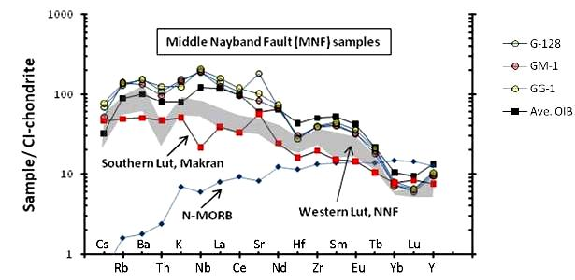
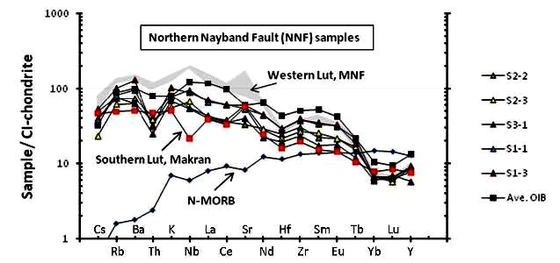

Fig.5. The distribution of the contents of rare and trace elements normalized to chondrite composition (Sun, McDonaugh, 1989), using (Saadat S, Stern C.R., 2011).

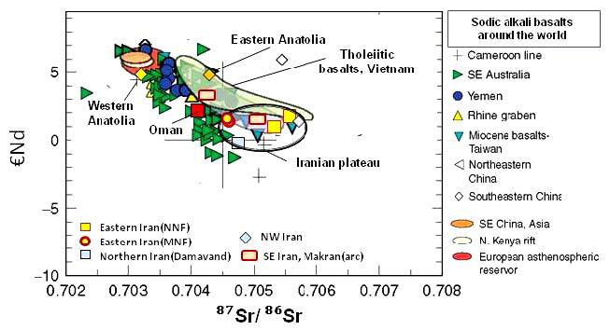

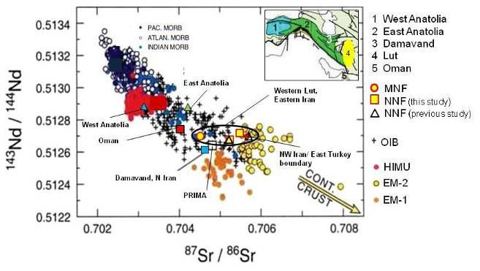

Fig. 6. Isotope systematics of igneous rocks in the region and standards using (Saadat S, Stern C.R., 2011).

Inclusions
Melt inclusions in this region were firstly investigated under the leadership of Prof. Prokofiev, IGEM RAS as well as fluid inclusions by E. Romanko et al. in 2000. Some notes and conclusions here are as folllows:
- Melt inclusions are not typical for the African super-plume-related intraplate igneous rocks. Intraplate rocks are confirmed by a tomography of known Ritsema’s team (Bull et al., 2009 etc). Also, melt inclusions are not typical or rare for shoshonite series rocks of Abbas Abad area. T crystallization of melt inclusions in similar Eocene shoshonite series rocks with Fe-skarn mineralization, West Iran is fairly high - ca 300ºC by V. Prokofiev et al.
- unusual fairly high temperature, 1150-1180º C - up to 1220º C melt inclusions were revealed in plagioclase of subduction-related K-dacite, sample 75-l by V. Prokofiev et al, 2011 (Prokofiev, 2000; Romanko et al., 2012, Fig. 7 and 8, Tables 2, 8.). This fairly deep, non-calc-alkaline rock was also affected by indirect (?) influence of a huge African super-plume, as proposed. Homogenization occurs under High T = 1150-1220º C (for comparing, for example, T much lower for acid volcanite of Quaternary Pektusan volcano, Korea, paper of O. Andreeva et al., IGEM RAS, Moscow, 2013). A higher viscosity of a glass provides more inclusions coexistence in a sample.
Maximal concentration on fluid CH₄ and other CH-based fluid inclusions were revealed in shallow intrusions on the contact with carbonate-rich host rocks in west Taftan zone; also in important Lar syenite massif with Cu-Au mineralization (Table 3, E. Romanko et al., 2000). Opposite, minimal data are in Cretaceous ophiolitic mainly melange rocks.

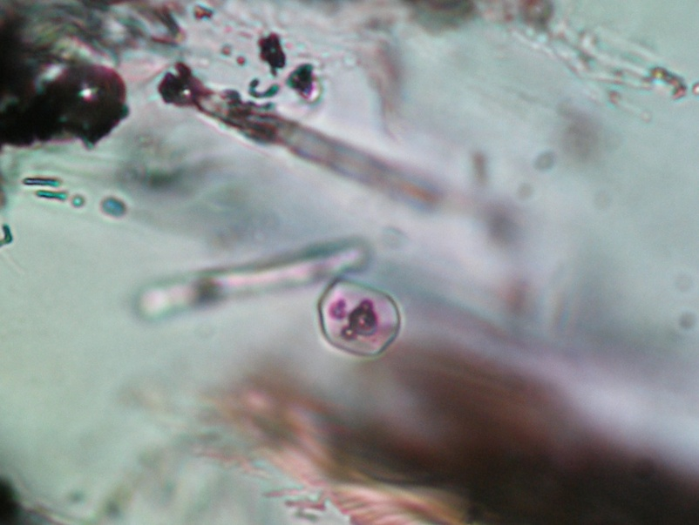

Fig 7. Sample R-75ia. East Iran. T=1150ºC.
View of melt inclusions in acid glass from Plagioclase

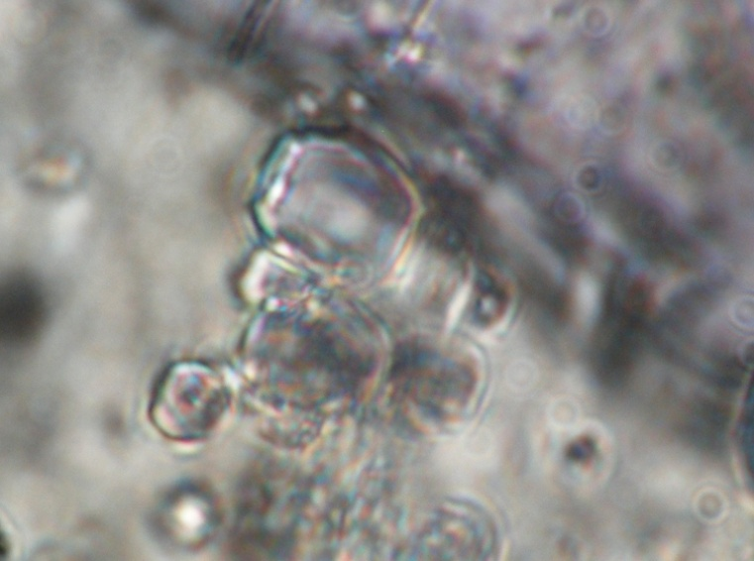
Fig 8. Sample R-75ia. Broad T interval in general is 1150-1220oC.
Homogenization of melt inclusions.
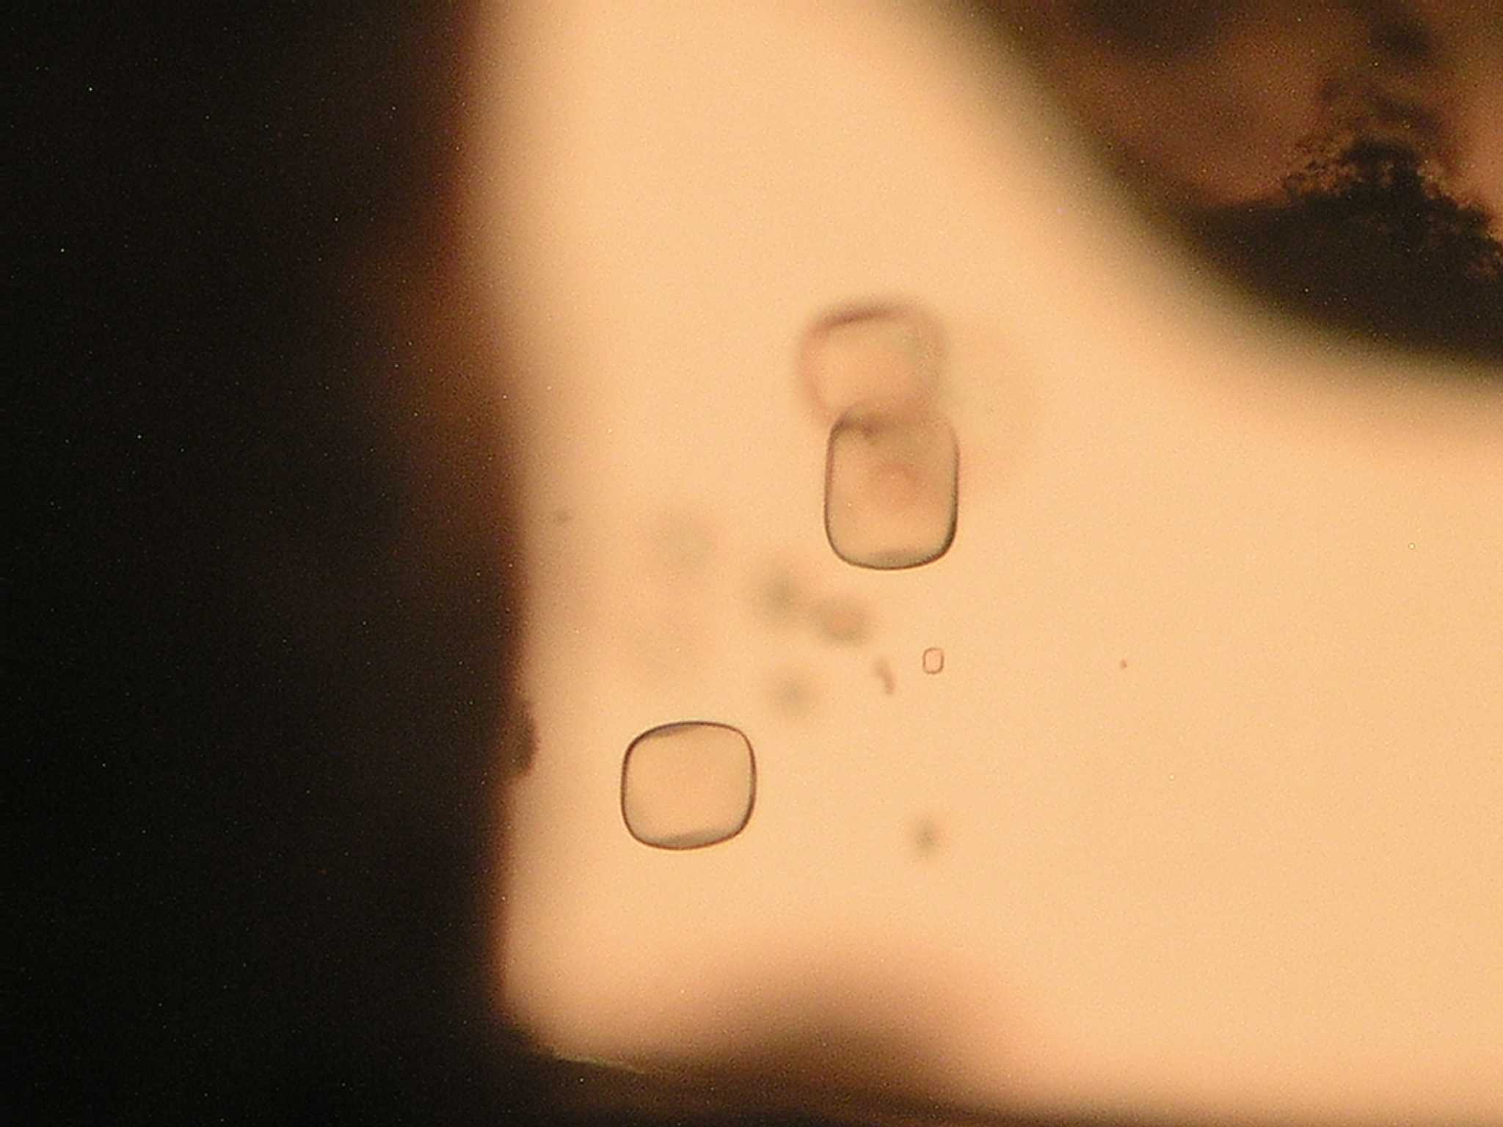

Fig 9. Sample R-82. Melt inclusions in Quartz, rhyolite, East Bazman volcano, T = 690oC. H2O content = 6 wt%. Naturally chilled melt inclusion. Maximal size of inclusion is ca 60 microns.
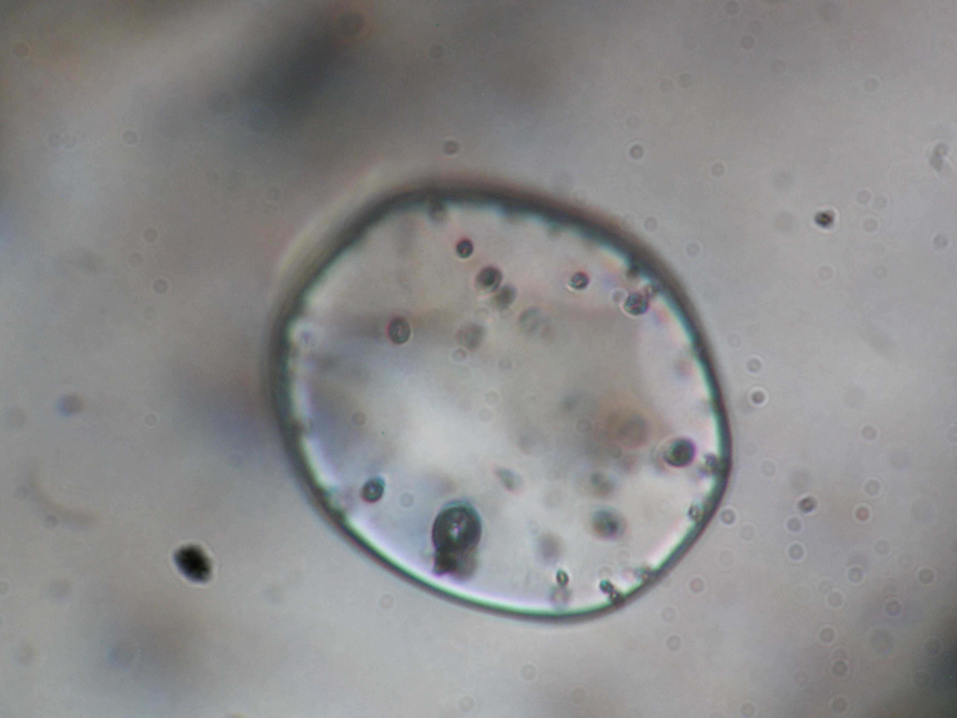

Fig 10. Sample R-82. Similar melt inclusion with gas bubbles in Quartz, rhyolite, East Bazman volcano, T = 630oC. After next T = 690oC gas bubbles will disappear. H2O content is up to 6 wt%.

Fig. 11. Spider-diagram or polycomponent one for Non-intraplate rocks, principally other, probably - subduction-related rocks. Circles – shoshonite series rocks, Abbas Abad copper deposit, Central Iran, M. Heidari’s samples, cross – intraplate rocks pf Lut block by Saadat et al, 2002, dots – Kurama Mt, Tien Shan, C3-P1 age, analogues of studied shoshonitic – latitic rocks. Usual positive anomaly by Pb. Ta – Nb deficit here is in subduction-related? rocks. For a comparison, example: Cross – principally OTHER intraplate rocks of Lut block by Saadat et al, 2002. | Fig. 12. Spider-diagram for intraplate rocks of East Iran, typical flat profiles. Sometimes -usual Pb positive anomaly. Triangiulars - R-70 – unnamed volcano (full plot with usual Pb – positive anomaly), R-71 – Haji temporary lake in a desert, not-full profile, no Middle - HREE data here, cross – intraplate rocks of Lut block by Saadat et al, 2002.

Fig 13. REE chondrite-normalized diagrams for Cenozoic intraplate rocks and Eocene subduction-related ones of Iran, N=6. Intraplate rocks are: R-70 (triangulars), R-71 (filled green triangulars), and crosses - sample from Lut block (Saadat et al., 2002). Circles – shoshonite – latite series rocks, Eocene (Pg2), Abbas Abad Cu mining area, N=2, samples of M. Heidari. Dots – rock of shoshonite- latite series, analogue, Kurama Mts, Middle Tien Shan, Late Carboniferous – Early Permian (C3-P1). Absent of Eu-deficit is typical for both intraplate and subduction-related rocks.

Intraplate rocks were derived from deeper mantle source versus subduction-related Eocene and Late Cenozoic rocks. This is supported by the following:
- Geological and petrographic and mineralogical data
- The general style of petrology and geochemistry of these rocks, we can the same on other regions
- Obvious geochemical materials, for example, the stable high K/Rb = 560-586-620 etc.
The region is expected to at least partial compensation of Pg2-Q aged compression and subduction-related Magmatism by intraplate magmatism. The latter, according to the imaging may be associated with the tail of the most powerful African superplume (Bull et al., 2009). There is also discussion in modeling - the partial screening of the plume push up plate, which is not an obstacle - it is known that plate moves may not stop movement of the tail superplume in lateral direction.

Metallogenic notes
Neogene rocks of the Lesser Caucasus is interesting for economic and non-economic metallogeny as:
- New Low-temperature Au-Ag, Hg, As, Sb, Cu-Mo with Au, Cu-Pb-Zn and Pb-Zn deposits and occurrences is proposed here,
- Non-ore raw – tuffs, slags, pumice etc. are of interest too.
Metallogeny of Cenozoic rock of East Iran was studied under the leadership of outstanding regional trio – Dr. Eugene Romanko, Dr. A. Houshmandzadeh, and Dr. M.A.A. Nogole-Sadat.
Calc-alkaline intrusive, extrusive, pyroclastic and volcanogenic-sedimentary rocks here are characterized by a common copper-gold (Cu-Au) metallogenic profile for Baluchestan and Sistan Province in East Iran, as in the whole Sahand – Bazman volcanic-plutonic belt of Iran. The overwhelming majority of occurrences the study area is associated with magmatic complexes. Such metallogenic types were revealed here as:
- Multi-sulfide (Au-Mo-Cu-Pb-Zn) subvolcanic porphyry type;
- Au-As-Hg-W-Mo-volcanic exhalation one;
-Low-sulfide gold-silver plutonic one;
-Gold-copper (Au-Cu) skarn and plutonic-hydrothermal one (E. Romanko et al., 2000; data by Pars Kani Co, 2003 by Daliran et al., 2005) using also known data on mineralization of different region including former USSR / CIS (Prokofiev et al., 2000; Vikentiev et al., 2004 etc.);
-Sulfide, sulfur, alunite exhalation, surface one;
-Native-copper-sulphide volcanogenic one with zeolites;
-Silver volcanogenic sulphide (+ gold?) one.
Thus, intraplate rocks are strongly specialized in REE, P (usual process), then in Sr, Ba, U, Th due to nowdays materilas. So, tectonic-magmatic, and as revealed E.Romanko – metallogenic zonation in the region was revealed in the region studied (at least in the Central – East Iran). Younger magmatic products are in the northeast of region due to lithosphere subduction and decreasing of Afrocan superplume activity in the same direction. Subduction-related (1 group of rocks) dominated calc-alkaline rocks and shoshonites-latites, and, intraplate African superplume-related (Laverov et al., 2004; Yarmolyuk, personal communication, 2013, etc.) midalkaline – alkaline rocks including known Pleistocene carbonatites of Hanneshin, Afghanistan and, also, of one of Arabia are subordinated (2 group of rocks). Rocks of 1 and 2 groups are interpreted by us as a tectonic-magmatic couple due to one from physics etc. In this case, at least, partial compensation of subduction compression by the intraplate extension is possible. Cenozoic intraplate rocks intraplate carbonatite-derived depth of the melt - an argument in favor of the African superplume influence on the magma plume of a large region, which is in agreement with effective tomography of the well-known J. Ritsema’s team (Bull et al., 2009).

Oil and gas, hydrocarbons (HC), some notes
There are known materials about of Caspian Sea OIL / HC resources or productivity decreasing in north – northeast (N - NE) tectonic direction or lineament as stressed by known Prof. V. Khain with co-authors in the Explanatory map of Caspian Sea region scale 1:2 500 000 etc. (Khain, 2001; Leonov et al., 2010). This decreasing is as follows: from extremely rich Persian Gulf to South – Middle – North Caspian Sea. It is in agreement with the increasing distance from the African superplume by effective tomography (Bull et al., 2010), tectonics etc.
More specifically, this HC super belt is as Persian Gulf – Russian Arctic coast, due to old Russian HC maps, ex., USSR oil structures map scale 1:2 500 000 etc. Also, important as HC traps salt domes in the east Persian Gulf are oriented due to this tectonic direction.
Some HC scientists believe now that there are no strong contradictions in combined biogenic and abiogenic data and that HC fields and position is Cenozoic (not Paleozoic - Mesozoic) due to high mobility of HC, ex. ca 1 m/year. So we see obvious deep, fault-related HC fluid input here, but the biogenic factor including favorable climate maybe important too. More data on HC peculiarities in the region studied needed, surely.

Conclusions
1. Some common geo-similarities on Cenozoic events in the region studied were revealed. At least, in East Iran important north-east tectonic-magmatic zoning and partly, metallogenic one (metallogeny under the leadership of known regional trio as E. Romanko, A.Houshmandzadeh, and M.A.A. Nogole-Sadat) due to African superplume activity exists here. It caused directly by known subduction of the Arabian plate under the Central Iran. African superplume activity strongly controls magmatism, “hot” regional tectonic regime, strongly controls magmatism, ‘hot’ tectonics and at least partly - metallogeny in the region studied. Also, African superplume close deal with known Jurassic Karoo flood basalts event in Africa, Paleogene magmatism in the East Africa and Paleogene subduction, Neogene, 11-9 Ma opening of Red Sea etc., and probably, delamination of a lithospheric slab in East Mediterranean in Miocene and as a result – lack of the regional Cu-porphyry mineralization versus economic one in Eocene.
2. Two different types of Cenozoic magmatic rocks exist in the region studied: 1 – intraplate alkaline and subalkaline rocks and 2 – shoshonite - latite series rocks and calc-alkaline ones mainly dealing with subduction – collision events. Low crystallization temperature – 690oC and High H2O content up to 6 wt. %, and natural melt chilling were revealed for a probably Quaternary subduction-related rhyolite of the Bazman volcano (all data on melt inclusions led by V. Prokofiev) Sudden high/very high crystallization temperature, up to 1220oC on melt inclusions in High-K probably subduction-related of remnant subduction-related dacite were received too. Otherwise, for intraplate rocks as well for shoshonite – latite subduction related ones melt inclusions are not typical due to proposed warm conditions.
3. Eocene (Pg2) subduction-related shoshonite – latite series rocks almost in the whole region are characterized by an economic Cu-Au mineralization with a subordinate different mineralization (Cu-Pb-Zn-Au-Ag, Hg-As, Au-Ag low-sulphide, Ag-sulfide with Au (?) etc.). Cu mineralization deals with deep basic enriched water-containing source. Cu mineralization disappears with time and higher in general magmatic section after disappears of relation with deep enriched source using (Haschke et al., 2010). Intraplate rocks bear, at least, REE, P, also Sr, Ba, Th, and U mineralization.
We are extremely grateful to outstanding regional trio - Drs. E.Romanko†, A. Houshmandzadeh, and M.A.A.Nogole-Sadat for their leadership in the field works and comprehensive care, also – to famous Prof. V. Khain from the Lomonosov MSU (consulting and advise), N.Bozhko, M. Goncharov, V.V.Slavinsky (long discussions), B. Zolotarev and V.Lyakhovich†, V.Yarmolyuk, V. Trifonov, V. Burtman, I. Pospelov, Yu. and M.Leonov, D.Alexeev; G.Karpova, M.Buyakayte, D.Astafiev, I.Gablina, Yu.Malinovsky, S. Palandzhyan and G.Nekrasov, A.Knipper†, S.Ruzhetsev†, G.Makarychev†, V.Rusinov†, I. Kravchenko-Berezhnoy, A.Girnis, A.Pertsev, A.Mokhov, V.Volkov, N.Tarasov; S.Bubnov, A.Gurbanov, and A.Dockuchaev; G. Moralev; also to A.Meskhi from Kazan, Russia; S.M.Tabatabaeimanesh, M.Hosseini, M. Ziaii, and more other geo-specialists for discussion, analytical help etc.
This work was supported by the RF Basic Research, project 03-05-64805.

REFERENCES
      - Abdullah S., Chmyrev V., Dronov V., Ed., 1980. Geology and Mineral Resources of Afghanistan. Moscow: Nedra. Book 1, p. 535, Book 2, 336 p. (in Russian).
      - Alinaghi A., Koulakov I., Thybo H., 2007. Seismic tomographic imaging of P- and S-waves velocity perturbations in the upper mantle beneath Iran. Geophysical J. International, 169, pp. 1089-1102.
      - Artemiev M., 1971. Some features of the deep structure of the Mediterranean type basins according to isostatic gravity anomalies. Bull. Moscow Society of Naturalists, Dept. Geol., no 4, pp. 30-41 (in Russian).
      - Bogatikov O.A, Kovalenko V.I., Yarmolyuk V.V., Bubnov S.N., 1987. Series of igneous rocks: problems and solutions. Reports of the Academy of Sciences of the USSR, Series Geol, no 3, pp. 3-12 (in Russian).
      - Bortnikov N.S., Prokofyev V.Yu., 2007. Major mesothermal gold ore deposit of Russia: composition and origin of ore-forming fluids // Digging Deeper. Proceedings of the Ninth Biennial meeting of the society for geology applied to mineral deposits. Dublin, Ireland, 20th-23rd august 2007. Dublin: Published Irish Association for Economic Geology, pp. 793-796.
      - Bortnikov N.S., Vikentiev I.V., 2004. Modern mineral-formation in the oceans. Ore deposits and ore-forming proce sses. M. IGEM, pp. 325-356. (in Russian).
      - Bull A.L., McNamara A.K., Ritsema J., 2009. Plume clusters and thermochemical piles. Earth Planet. Sci. Lett. Vol. 278, pp. 152–162.
      - Burtman V.S., 2012. Tien-Shan and High Asia. Geological Institute Transactions. M: GEOS, 188 p. In Russian.
      - Dilek Y., Imamverdiyev N.A., Altunkaynak S., 2010. Geochemistry and tectonics of Cenozoic volcanism in the Lesser Caucasus (Azerbaijan) and the Peri-Arabian region: Collision-induced mantle dynamics and its magmatic fingerprint // International Geology Review, vol. 52, issue 4-6, pp. 536-578.
      - Haschke M., Ahmadian J., Murata M., McDonald I., 2010. Copper mineralization prevented by arc-root delamination during Alpine-Himalayan collision in Central Iran. Economic Geologists, v. 104, pp. 885-895.
      - Hushmand-Zadeh A., Nabavi M.H., 1986. Metamorphic Map of Iran Scale 1: 2,500,000. Tehran: Geol. Survey. Iran.
      - Imamverdiyev N.A. 2000. Geochemistry of Late Cenozoic volcanic complexes Lesser Caucasus Baku. Nafta-Press. 2000. 192 p.
      - Imamverdiyev N.A. 2008. Delamination of subducted lithospheric slab as the cause of Late Cenozoic volcanism in the Lesser Caucasus. News of State Baku University. Natural sciences Series. no 3, pp.536-578.
      - Khain V., 2001. Tectonics of Continents and Oceans (year 2000). Moscow: Scientific World, 2001. 606 p. (in Russian).
      - Khain V., Goncharov. M., 2006. Endogenic processes of different tectonic settings. Herald of MSU. Vol. 5. pp. 15-23.
      - Knipper A., Dobretsov N., Bogdanov N., 1992. Ophiolites and “orogenic lherzolites” of Bet Cordillera, Spain. Reports of the Academy of Sciences. Geological Series. N 12, pp. 8-24. In Russian.
      - Koronovsky N.V., Demina L.I., 1999. Collisional stage of the Caucasian sector Alpine fold belt: geodynamics and magmatism // Geotectonics, no 2, pp. 17-35.
      - Koronovsky N.V, Lomize M.G., 2006. Tectonic accretion and collision as the steps of forming intra-continental fold belts. Areas of active tectonics in modern and ancient history of the Earth / Materials of 39 Tectonic meeting, vol. 1, Moscow: GEOS. pp. 353-357 (in Russian).
      - Laverov N., Kovalenko V., Yarmolyuk V. et al., 2006. The latest volcanic activity in Northern Eurasia: Zoning and environment of formation. Russian Academy of Sciences Reports. vol. 410. no 4, pp. 498-502 (in Russian).
      - Leonov Yu., Volozh Yu., Antipov M. et al., 2010. Consolidated crust of Caspian region. M. GEOS. 64 p. (in Russian).
      - Luchitsky I.V., 1985. Palaeovolcanology. Moscow: Science (Nauka), 235 p. In Russian.
      - Marakushev A.A., 1988. Petrology. Moscow. MSU publishing, 206 p. In Russian.
      - Milanovsky E.E., Koronovsky N.V., 1973. Orogenic volcanism and tectonics of the Alpine belt of Eurasia. Moscow: Nedra, 280 p (in Russian).
      - Nogole-Sadat, M.A., 1985. Les Zones de Decrochement et les Virgation Structurales en Iran: Geol. Survey of Iran, Report, 55, 259 p.
      - Pospelov I., 2009. Tectonics of Pamir. Tectonics and geology. V. 5, pp. 15-25.
      - Prokofiev V.Yu., 2000. Geochemistry of ore-forming fluids of hydrothermal gold deposits of different genetic types according to the study of fluid inclusions. Moscow. Science (Nauka), Novosibirsk, 192 p.
      - Prokofiev V.Yu., Bortnikov N.S., Zorina L.D. et al., 2000. The Darasun intrusive-related gold-base metal deposit, Eastern Transbaikalia, Russia: Petrochemical, melt and fluid inclusion, REE and stable isotope (O, C, and S) studies // Applied Mineralogy. Rammlmair et al., Eds. Balkema, Rottertdam, Brookfield, 399-402 pp.
      - Romanko E., Kokorin Y.., Krivyakin B. et al., 1984. Outline of metallogeny of Anarak Area (Central Iran). Ministry of mines and metals // Geological Survey of Iran. Rep. 21, Tehran. Technoexport, 136 p.
      - Romanko E., Voinkov D., Houshmandzadeh A. et al., 2000. Characteristic features of ore mineralization in the Sistan-Baluchestan Province, SE Iran: evidence from fluid inclusions data / International conference on geology of Mediterranean belt. Absracts. Beograd.
      - Romanko E., Houshmandzadeh A., Nogol-Sadat M.A.A. et al., 2000. Metallogenic zonation in Seistan and Baluchestan Province, East Iran. Reports of Russian Academy of Sciences. V. 370, N 1, pp. 76-79. (In Russian).
      - Romanko E., Romanko A., Meskhi A., 1998. On a Geology and Geochemistry of Mesozoic-Cenozoic igneous rocks in NE Algeria // Reports of Academy of Sciences (RAS), vol. 362, no 2, pp. 236-238 (in Russian).
      - Romanko A., 2005. New data on Cenozoic subalkaline intraplate rocks the East Iran. // Reports of the Academy of Sciences, v. 404, no 4, pp. 510-513.
      - Romanko A., Imamverdiyev N.A., Prokofiev V., Vikentiev I., Savichev A., Stepanov S., 2013. Alpine tectonic-magmatic-metallogenic peculiarities in West Baluchestan, Middle East: new data, “hot” tectonics, inclusions, discussion, hydrocarbons (HC), and constraints // Universal Journal of Geoscience, vol. 1, pp. 130-138.
      - Romanko A., Imamverdiyev N. A., Prokofiev V., Heidari M. et al. 2012. On Cretaceous – Quaternary magmatic – tectonic - metallogenic peculiarities in east Iran and South Tajikistan: new data melt inclusions, constraints, and some problems. European Seismological Commission Assembly. ESC. Book of abstracts. M. Polygraph, pp. 154-155.
      - Rusinov V.L., 1985. Propilites and propilitization. M.: Nauka. 185 p. In Russian
      - Sandwall E., Turkell N., Zor E. et al., 2003. Shear wave splitting a young continent collision // Geophys. Res. Lett., 30. no 24 b, pp.185.-194.
      - Trifonov V., Ruzhentsev S., 1984. Tectonic napes in East Pamir and tectonic layering. Episodes. 32 IGC. Special Issue. pp. 15-20.
      - Vikentiev I.V., Yudovskaya M.A., Mokhov A.V. et al. 2004. Gold and PGE in massive sulphide ores of the Uzelginsk deposit, Southern Urals, Russia // Canadian Mineralogist. v. 42, no 5, pp. 651-665.
      - Yarmolyuk V.V., Kovalenko V.I., 2003. Deep geodynamics, mantle plumes and their role in Central-Asian mobile belt formation. Petrology. V. 11. No 6. pp. 556-586. In Russian.
      - Yarmolyuk V.V., Kovalenko V.I., Bogatikov O.A., 1990. South Baikal "hot spot" mantle and its role in the formation of the Baikal Rift region. Reports of Russian Academy of Sciences. V. 312. No 1. pp. 187-191. In Russian.

This work was supported by the RF Basic Research, project 03-05-64805.

МАЛЫЙ КАВКАЗ-ВОСТОЧНЫЙ ИРАН, БЛИЖНИЙ ВОСТОК: НЕКОТОРЫЕ МАТЕРИАЛЫ ПО ГЕОЛОГИИ И МЕТАЛЛОГЕНИИ, "ГОРЯЧАЯ"
ТЕКТОНИКА, СВЯЗАННЫЕ С ДЕЯТЕЛЬНОСТЬЮ АФРИКАНСКОГО
СУПЕРПЛЮМА, РАСПЛАВНЫЕ И ФЛЮИДНЫЕ ВКЛЮЧЕНИЯ,
НЕКОТОРЫЕ ДАННЫЕ ПО УГЛЕВОДОРОДАМ,
ПРОБЛЕМЫ И ОГРАНИЧЕНИЯ

Н.А.ИМАМВЕРДИЕВ, А.РОМАНЬКО, Ш.Ф.АБДУЛЛАЕВА,
В.ПРОКОФЬЕВ, И.ВИКЕНТЬЕВ, А.САВИЧЕВ,
А.СТЕПАНОВ, М.ХЕЙДАРИ, Б.РАШИДИ

РЕЗЮМЕ

Кайнозойские тектоно-магматические и металлогенические события Малого Кавказа и востока Ирана, Ближний Восток, имеют общие черты. Существует важная геолого-металлогеническая +- нефтяная или углеводородная корреляция для альпийского времени (металлогения востока Ирана – под руководством выдающегося регионального трио: Е.Ф. Романько, А. Хушманзаде и М.А.А. Ноголь Садат). Геологическая северо-восточная зональность и «горячая тектоника» (включая, возможно, и известную деламинацию литосферы в течение коллизии 13 млн. лет ), обусловленная активностью Африканского суперплюма, важна для региона. Выяснена, что внутриплитные щелочные и субщелочные расплавы региона, включая четвертичные карбонатиты Ханнешина, Афганистан, генерировали из обогащенного мантийного источника Африканского суперплюма, богатыми высокозарядными литофильными элементами– HFSE (Nb, Ta, Zr, Y, P, Ti и т.д.). Позднекайнозойские высоко-калиевые известково-щелочные породы Малого Кавказа могут быть также объяснены активностью указанного суперплюма, несмотря на формально субдукционные геохимические метки.
Имеются важные материалы об общей субмеридианальной зональности углеводородов здесь. Это может быть аргументом в пользу и глубинного вклада углеводородов, наряду с традиционной их трактовкой. Важная региональная Cu-Au порфировая и др. металлогения связана с породами шошонит-латитовой серии преимущественно эоценового возраста, формировавшимися в результате субдукции Аравийской плиты под блок Центрального Ирана.

Ключевые слова: центральная часть Альпийско-Гималайского пояса, Малый Кавказ-Восточный Иран, Ближний Восток, геология, геохимия, тектоника, магматизм, металлогения, Африканский суперплюм, деламинация, минералогия, расплавные и флюидные включения, северо-восточная (СВ) тектоно-магматическая-металлогеническая +нефть/углеводородная (УВ) зональность.

KİÇİK QAFQAZ-ŞƏRQİ İRAN, YAXIN ŞƏRQ: GEOLOGİYA VƏ METALLOGENİYA HAQQINDA BƏZİ MATERİALLAR, AFRİKA SUPERPLYUMİNİN FƏALİYYƏTİLƏ ƏLAQƏDAR OLAN “QAYNAR” TEKTONİKA, ƏRİNTİ VƏ FLYÜİD DAXİLOLMALARI, KARBOHİDROGENLƏR HAQQINDA BƏZİ MƏLUMATLAR, PROBLEMLƏR VƏ MƏHDUDİYYƏTLƏR

N.Ə.İMAMVERDİYEV, A.ROMANKO, Ş.F.ABDULLAYEVA,
V.PROKOFYEV, İ.VİKENTYEV, A.SAVİÇEV,
A.STEPANOV, M.HEYDARİ, B.RAŞİDİ

XÜLASƏ

Kiçik Qafqazın və İranın şərqinin, Yaxın Şərqin kaynozoy tektono-maqmatik və metallogenik hadisələri ümumi xüsusiyyətlərə malikdirlər. Alp dövründə əhəmiyyətli geoloji-metallogenik+neft və ya karbohidrogen korrelyasiyası müəyyən edilmişdir (İranın şərqinin metallogeniyası görkəmli regional trio – Y.F.Romanko, A.Xuşmanzadə və M.A.A.Noqol Sadatın rəhbərlikləri altında aparılmışdır). Afrika superplyuminin fəallığı ilə əlaqədar olan geoloji şimal-şərqi zonallıq və “qaynar tektonika” (13 mln. il kolliziya dövründə məlum olan litosferin delaminasiyası da daxil olmaqla) region üçün əhəmiyyət kəsb edir. Müəyyən edilmişdir ki, Xanneşin, Əfqanıstanın dördüncü dövr karbonatitləri də daxil olmaqla regionun qələvi və mülayim qələvili ərintiləri yüksək nüvəli litofil elementlərlə HFSE (Nb, Ta, Zr, Y, P, Ti və b.) zəngin olan Afrika superplyuminin zənginləşmiş mantiya mənbəyindən generasiya etmişdir. Kiçik Qafqazın gec kaynozoy yaşlı yüksək kaliumlu kalsiumlu- qələvili süxurları formal olaraq subduksiya geokimyəvi nişanəsi olmasına baxmayaraq göstərilən superplyuminin fəallığı ilə izah edilə bilər. Burada karbohidrogenlərin ümumi submeridional zonallığı haqqında materiallar vardır. Bu tradision nəzəriyyə ilə bərabər karbohidrogenlərin dərinliklə əlaqəsinin xeyrinə arqument kimi istifadə oluna bilinər. Ərəbistan plitəsinin Mərkəzi İran blokunun altına subduksiyası nəticəsində əmələ gəlmiş regional Cu-Au porfir və başqa metallogeniya eosen yaşlı şoşonit-latit seriyasının süxurları ilə əlaqədardır.

Açar sözlər: Alp-Himalay qurşağının mərkəzi hissəsi, Kiçik-Qafqaz-Şərqi İran, yaxın Şərq, geologiya, geokimya, tektonika, maqamtizm, metallogeniya, Afrika superplyumi, delaminasiya, mineralogiya, ərinti və flyüid daxilolmaları, şimal-şərq (Şm-Ş) tektono-maqmatik-metallogenik+neft/karbohidrogen zonallığı.

Redaksiyaya daxil oldu: 18.09.2014-cü il
Çapa imzalandı: 05.11.2014-cü il

